USDA Forest Service | Region 8
Cherokee National Forest
Ocoee Ranger District
The USDA Forest Service, Cherokee National Forest is seeking to hire several temporary/seasonal positions that are highly motivated and energetic to be a part of the aquatic resources crew. The following Biological Science Technician (Fisheries) (GS-0404-05) positions are located at the duty station of Benton, Tennessee with the Ocoee Ranger District. The purpose of this Outreach Notice is to inform prospective applicants of this upcoming opportunity which will be advertised on www.usajobs.gov.
Phase 2 Temporary Seasonal Positions

Biological Science Technician (Fisheries)

GS-0404-05

Ocoee Ranger District
Benton, TN
OUTREACH NOTICE

Description of duties associated with this position: The incumbent will work under the supervision of the South Zone Hydrologist. The temporary position will serve as a member of the aquatics team and perform a wide variety of duties.
This is a SEASONAL TEMPORARY position with a proposed maximum six-month tour schedule (not to exceed 1039 hours). The anticipated start date for this position is between January and March 2024. The work is 40 hours a week, 4 days a week. Duties are as follows, but not limited to:
- Serves as a member of the aquatics program on the Forest to achieve land and resource management goals. The aquatics program is an integrated team consisting of hydrologists, fisheries biologists, and technicians.
- Conducts field surveys such as stream habitat conditions, culvert inventory, and aquatic species surveys. Assists as needed with hydrologic surveys.
- Assists with watershed restoration efforts including stream restoration, wetland restoration, road decommissioning and aquatic organism passage at road-stream crossings.
- Assists with post-fire assessments and determination of short- and long-term effects of fire as well as assisting with possible rehabilitation and restoration actions.
- Uses data management skills and attention to detail while recording survey and monitoring data.
- Operates government vehicles on forest roads and navigates to site locations in the forest.
- Assists with public-facing programs such as freshwater snorkeling and youth nature days.

Qualification Requirements:

Those who are interested must meet the qualification requirements for the 0404 series that is covered by the U.S. Office of Personnel Management (OPM) Qualification Standards for General Schedule Positions –Biological Science Technician (Fisheries) GS-0404-05. The OPM Qualification Standards Handbook Manual is available for review on the Internet at Qualifications for the 0404 series can be found here: https://www.opm.gov/policy-data-oversight/classification-qualifications/classifying-general-schedule-positions/occupationalhandbook.pdf
For additional information about the position or the Forest, please contact Nancy Gibson, the South Zone Hydrologist, at nancy.gibson@usda.gov.

About the Cherokee National Forest:
Tennessee’s only National Forest, the Cherokee spans 10 Eastern Tennessee counties from Chattanooga to Bristol. The Forest covers approximately 660,000 acres and lies along the state’s border with North Carolina. The Cherokee is comprised of four ranger districts, two of which lie south of the Great Smoky Mountains National Park, and two are located north of the Park (North Zone & South Zone). There is also have a Job Corp Center located on the north end of the Forest. The Forest lies entirely within the Southern Appalachian Mountains with elevations ranging from approximately 1200’ to over 5000’. The Cherokee National Forest employs approximately 155 employees.
The Cherokee National Forest is internationally known for its scenic beauty and abundant outdoor recreation opportunities. The Forest is home to 30 developed campgrounds and as many picnic areas, over 700 miles of trails, seven whitewater rivers, two Forest Service scenic byways, and the Ocoee Whitewater Center (OWC).
The Ocoee/Hiwassee and the Tellico Districts, making up the South Zone of the Forest, are the two southern most ranger districts and administers approximately 300,000 acres in three counties – Polk, McMinn, and Monroe.
Except for the Recreation Program, the management structure and activities of the South Zone are shared between both districts. All program areas are zoned, except for the Recreation programs. Based on our current workforce, the South Zone has been designed to efficiently divide the duties of the districts between planning and implementation. The Tellico District has assumed the planning side of the zone, while the Ocoee/Hiwassee District is charged with implementation of all zoned program activities.
Benton, Tennessee is county seat of Polk County. It is tucked into the Appalachian Mountains in the southeastern corner of Tennessee. It is blessed with 3 beautiful and distinctly different rivers. The Hiwassee, on the northern border, is one of the south’s premier trout fisheries, the Conasauga, on the southern border, is home to 60+ species of fish and rivals an ocean reef for snorkeling opportunities. Located in the center of the county is the Ocoee River, a world class rafting/kayaking venue which hosted the 1996 Olympic Canoe/Kayak competition. This area also boasts 50 plus miles of World Class Mountain Bike Trails and many miles of hiking trails which often lead to water falls or offer a glimpse of the abundant wildflowers in spring or fall colors that rival New England. Summers are temperate, and winters are generally mild with very small snow fall amounts. Winter sports are only a few hours away in nearby Gatlinburg, gateway to the Great Smoky Mountains National Park.

For additional information on living in the Cleveland-Bradley/Polk County area and southeast Tennessee visit: http://www.clevelandchamber.com/information/index.htm or www.southeasttennessee.com

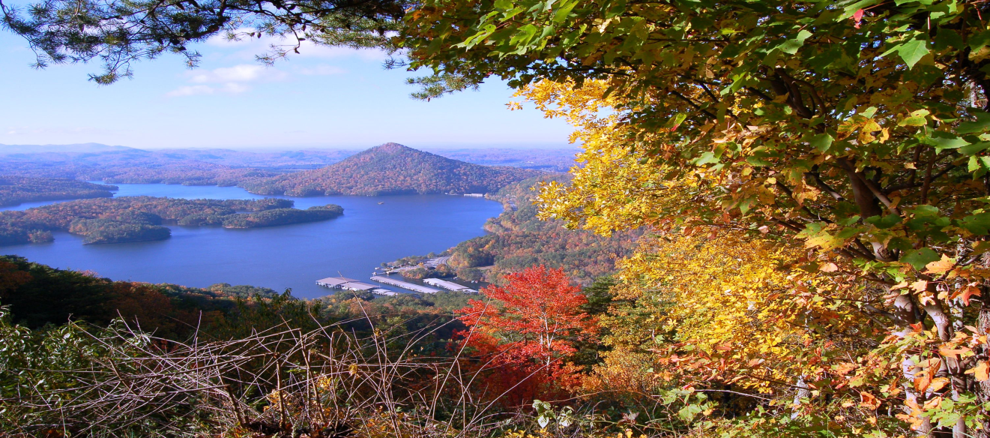

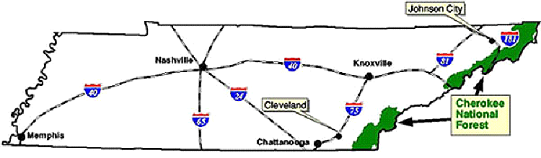

https://www.fs.usda.gov/main/cherokee/home

OUTREACH NOTICE FORM
USDA Forest Service
Cherokee National Forest
Benton, TN
Biological Science Technician (Fisheries)
2024 Temporary/Seasonal Employment Opportunity

If you are interested in this opportunity, please apply for the position, and email the completed interest form along with your resume, to nancy.gibson@usda.gov. (Please include “Aquatic Technician” in the subject line of your message.)
PERSONAL INFORMATION:
Name: |  | Date:
Address: |  | Phone:
 |  | e-mail:
Are you currently a federal employee? |  | YES NO
Current title/series/grade/location/classification:

(e.g., Career, Career-Conditional, Excepted-ANILCA, Excepted VRA, etc.)
Briefly describe why you will be a quality candidate for this position:

